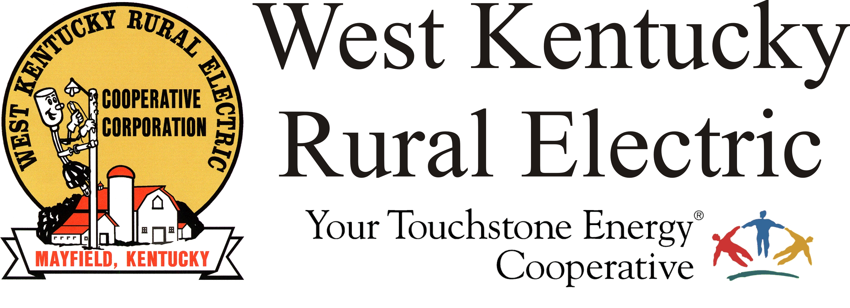

West Kentucky RECC Wednesday Evening
Storm Damage Update

(Mayfield, Ky.) Dec. 15, 2021 (7:00 p.m.) – Tonight West Kentucky Rural Electric Cooperative has approximately 400 homes, farms, and businesses still without power, down from a high of 28,000 five days ago. The outages are in along the path of the EF4 tornado through Graves and Marshall counties.
“We are so grateful for our members' support and patience during this time,” said WKRECC President & CEO David Smart. “We are also thankful for all the individuals and organizations from across the country that are here helping those affected find a path forward.”
The National Weather Service’s preliminary report shows EF4 damage from Fulton County to Muhlenberg County, Kentucky. Friday’s tornado had estimated peak winds of 190 miles per hour. The length was estimated at 128 miles with a width of 1 mile or more.
The survey found massive impacts along most of the tornado track, with the worst damage being in Cayce, Mayfield, north of Benton, south of Princeton, Dawson Springs, Barnsley and Bremen.
The Mayfield office is expected to reopen on Monday, Dec. 20. The Murray and Benton offices are open daily from 7:30 a.m. to 4:00 p.m. Customer service is available at 1-877-495-7322. Please note that all three payment kiosks are operational.
Heavy rain and wind are forecast for tomorrow. Please be aware that these conditions could cause storm-weakened trees/limbs to fall, creating new outages. Please be safe and call 1-877-495-7322 if you need to report a problem.
To report an outage, call 1-877-495-7322 and use option 1 to leave a recorded message.
Reminders:
- Be alert for scams. If you receive a call demanding payment and threatening to disconnect your service, don’t be a victim!
- Disconnects for non-payment are temporarily suspended. We will announce when disconnects resume.
___________________________________________________________

Georgann Lookofsky, 270-804-1701 or glookofsky@wkrecc.com

